CHAPTER 1
INTRODUCTION
1.1 ABSTRACT
The rapid advancement of Artificial Intelligence (AI), Internet of Things (IoT), and embedded systems has enabled the development of intelligent and autonomous solutions for modern home environments. However, traditional surveillance and automation systems remain largely passive, fragmented, and dependent on manual control.
This project presents GOKU (Groq-integrated Operational Kinetic Unit), an AI-powered cybernetic surveillance rover designed to provide intelligent monitoring, autonomous navigation, and smart home automation within a unified platform. The system integrates a dual-controller architecture using a Raspberry Pi 5 for high-level processing and an ESP32 for real-time hardware control.
The rover is equipped with a multi-sensor infrared (IR) array for obstacle detection, a vision system for real-time monitoring, and relay/contactors for safe appliance control. Additionally, it incorporates AI-based voice interaction to enable natural communication between the user and the system.
The proposed system enhances safety, efficiency, and user convenience by combining mobility, intelligence, and automation into a single platform, making it suitable for modern smart home applications.

1.2 INTRODUCTION
Advancements in robotics, artificial intelligence, and IoT have significantly transformed automation and surveillance systems. Traditional systems such as CCTV cameras and basic home automation devices provide limited functionality due to their lack of mobility, adaptability, and intelligent interaction.
Modern systems are expected to perform real-time monitoring, autonomous decision-making, and seamless user interaction. Mobile robotic platforms further enhance these capabilities by enabling active surveillance and dynamic environment interaction.
In this context, the proposed system aims to develop a smart, mobile, and interactive solution that integrates autonomous navigation, intelligent processing, and safe automation mechanisms into a single platform.
1.3 EXISTING SYSTEM
Existing surveillance and home automation systems are primarily based on static and passive technologies such as CCTV cameras and application-based control systems. These systems lack mobility, real-time interaction, and intelligent decision-making capabilities.
Furthermore, most home automation solutions are fragmented across multiple applications, making them complex and less user-friendly. In addition, standard relay modules used in these systems are not suitable for handling high-power electrical loads, which can lead to safety risks such as overheating and equipment failure.
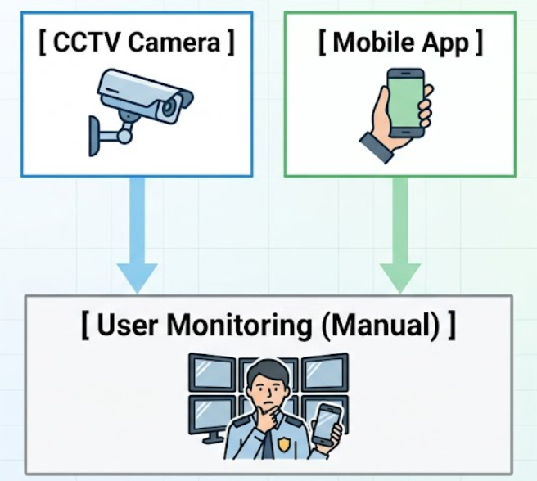
Figure 1.1: Traditional Passive Surveillance and Fragmented IoT Systems
The figure 1.1 illustrates the structure of traditional surveillance and home automation systems, where components operate independently without integration. It highlights the lack of communication between devices and the dependency on manual monitoring.
1.4 PROBLEM STATEMENT
Despite technological advancements, current systems face several limitations:
- Passive monitoring requiring continuous human supervision
- Lack of mobility and real-time responsiveness
- Fragmented control systems across multiple platforms
- Limited intelligence and user interaction
- Unsafe handling of high-power electrical loads
These challenges highlight the need for an integrated system that provides autonomous operation, intelligent interaction, and safe control mechanisms.
1.5 PROPOSED SYSTEM
The proposed system, GOKU, is an intelligent cybernetic surveillance rover that integrates robotics, AI, and IoT technologies into a unified platform.
It employs a dual-controller architecture, where the Raspberry Pi 5 handles high-level processing such as AI-based interaction, and the ESP32 manages real-time hardware operations. The system supports autonomous navigation using a multi-sensor IR array, real-time monitoring through a vision system, and voice-based interaction using AI models.
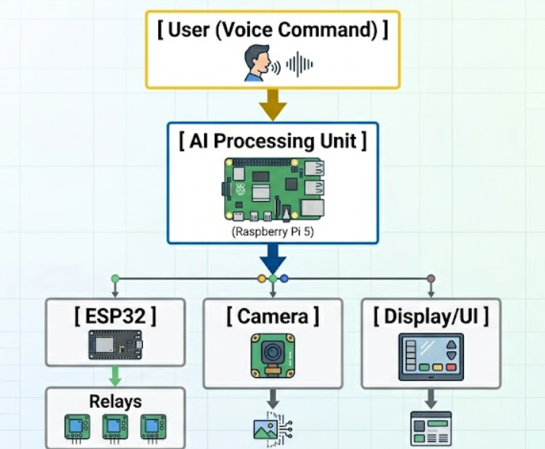

Additionally, it incorporates safe automation mechanisms using relay modules and industrial contactors, enabling reliable control of both low-power and high-power appliances.
Figure 1.2: Overall Proposed System Architecture
The above figure 1.2 shows the overall architecture of the proposed GOKU system, illustrating the interaction between the user, AI processing unit, controllers and actuators. It explains how data flows through different components to achieve intelligent operation.
1.6 OBJECTIVES
The main objectives of the project are:
- To design and develop a mobile robotic rover for surveillance and automation
- To implement autonomous navigation using sensor-based obstacle detection
- To integrate AI-based voice interaction for natural communication
- To enable IoT-based control of household appliances
- To ensure safe handling of high-power electrical loads
1.7 METHODOLOGY
The proposed system follows a structured approach involving system design, hardware integration, and software implementation. Sensor data is continuously monitored for obstacle detection, while AI modules process user commands for decision-making.
The dual-controller architecture ensures efficient task distribution, where high-level processing is handled by the Raspberry Pi 5 and real-time control is managed by the ESP32. Communication between components is achieved through wireless protocols, enabling seamless system operation.
1.8 SCOPE
The scope of the project includes the design and implementation of a smart mobile system capable of:
- Autonomous and manual navigation
- Real-time surveillance and monitoring
- Voice-based user interaction
- Smart home automation
- Safe control of electrical appliances
The system is designed primarily for indoor environments and can be extended to applications in security, assistive technology, and industrial monitoring.
1.9 APPLICATIONS
The proposed system can be applied in various domains:
- Residential security and surveillance
- Smart home automation
- Assistive technology for elderly and disabled individuals
- Remote monitoring and telepresence
- Industrial inspection and safety monitoring
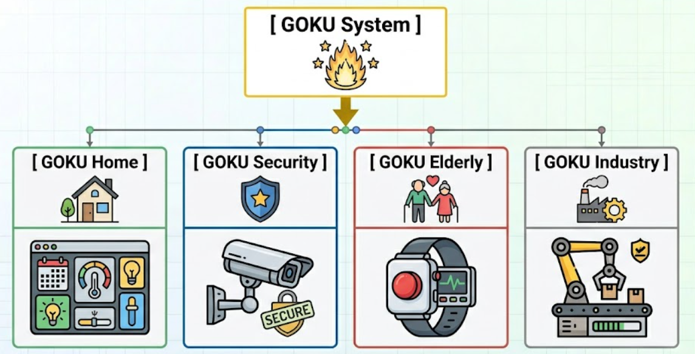
Figure 1.3: Application Areas of System
This figure 1.3 shows the various real-world applications of the proposed system, including home automation, security, and industrial monitoring. It demonstrates the versatility and scalability of the system.

CHAPTER 2
LITERATURE REVIEW
2.1 Line Follower Robot with Advanced Navigation
Title: Design and Implementation of a Line Follower Robot
Year: 2024
Authors: S. Shirmohammadi, F. Baghbani
Description:
This paper presents the design of a line follower robot with improved navigation and control strategies. The system uses sensor-based inputs and intelligent algorithms to achieve accurate path tracking and real-time decision-making. It enhances the robot’s ability to adapt to environmental changes and maintain stable movement. The study focuses on improving navigation efficiency and reducing errors during motion.
Adopted Methodology in Proposed System:
This literature is used to implement sensor-based navigation logic, where real-time input from sensors is processed to make movement decisions. This concept is applied in the autonomous patrol mode of the GOKU system for obstacle detection and path correction.
Advantages:
- Improves navigation accuracy
- Enables real-time decision-making
- Enhances autonomous movement
Disadvantages:
- Limited to line-based navigation
- Requires modification for complex environments
2.2 IoT-Based Wheelchair with Obstacle Detection
Title: IoT-enabled Moving Wheelchair with Obstacle Detection and
Continuous Health Monitoring
Year: 2024
Authors: M. Pakdaman, M. M. Sanaatiyan, et al.
Description:
This research introduces an IoT-enabled wheelchair system that integrates sensors for obstacle detection and real-time monitoring. The system uses microcontrollers and wireless communication to transmit data to cloud platforms. It provides continuous monitoring and improves safety through automated responses.
Adopted Methodology in Proposed System:
This literature is used to implement multi-sensor integration and IoT-based communication. The concept is applied in the GOKU system using a 6-sensor IR array and ESP32 to enable real-time obstacle detection and wireless control.
Advantages:
- Real-time monitoring
- Efficient sensor integration
- Supports IoT communication
Disadvantages:
- Depends on network connectivity
- Increased system complexity
2.3 Indoor Navigation and Mapping System
Title: Indoor Navigation and Mapping for Wheelchair People in KOE
Year: 2023
Authors: N. N. N. Hisham, N. A. C. Mustapha, A. M. Ibrahim
Description:
This paper focuses on indoor navigation systems designed to improve movement accuracy using mapping and sensing techniques. It enhances environmental awareness and supports structured navigation.
Adopted Methodology in Proposed System:
This literature is used to implement environment-aware navigation strategies. It is applied in the GOKU rover to enable effective movement and surveillance within indoor environments.
Advantages:
- Improves navigation accuracy
- Enhances environmental awareness
- Supports real-time sensing

Disadvantages:
- Requires mapping setup
- Less effective in dynamic environments
2.4 Kinematic-Based Motion Control System
Title: Sweeper Arm Mechanism Design on the Line Follower Robot with
Path Sensing Algorithm and Curvature-Driven Kinematic
Year: 2022
Authors: N. Charaspotiranatakul, W. Thitayanunwat, I. Rattanathavorn
Description:
This research presents curvature-based kinematic modeling and PWM control for smooth robotic movement. It focuses on achieving stable acceleration and efficient motion control.
Adopted Methodology in Proposed System:
This literature is used to implement PWM-based motor control for smooth acceleration and deceleration. It is applied in the motor driver system of the GOKU rover to ensure stable movement.
Advantages:
- Smooth motion control
- Efficient speed regulation
- Improved stability

Disadvantages:
- Requires precise calibration
- Increased complexity
2.5 Basic Line Follower Robot System
Title: Design and Implementation of a Line Follower Robot
Year: 2009
Authors: M. Pakdaman, M. M. Sanaatiyan
Description:
This foundational study explains differential drive mechanisms and motor control logic for robot movement using sensors and drivers.
Adopted Methodology in Proposed System:
This literature is used to implement differential drive and directional control logic in the GOKU rover for basic movement operations.
Advantages:
- Simple design
- Easy implementation
- Strong foundation
Disadvantages:
- Limited intelligence
- No obstacle detection
2.6 Human-Machine Interface System
Title: Design Considerations for a Personalized Wheelchair Navigation System
Year: 2007
Authors: D. Ding, B. Parmanto, H. A. Karimi, et al.
Description:
This paper focuses on designing user-friendly systems with improved human-machine interaction and accessibility.
Adopted Methodology in Proposed System:
This literature is used to design the human-machine interface by implementing intuitive interaction methods. It is applied in the GOKU system through voice-based communication.
Advantages:
- Improves usability
- Enhances interaction
- Focus on accessibility
Disadvantages:
- Limited robotics focus
- Outdated context

2.7 AI-Based Natural Language Processing System
Title: Google Generative AI SDK Documentation (Gemini)
Year: 2024
Authors: Google
Description:
This documentation provides support for integrating generative AI models capable of natural language processing and real-time responses.
Adopted Methodology in Proposed System:
This literature is used to implement natural language processing and AI-based response generation. It is applied in the voice interaction module of the GOKU system.
Advantages:
- Advanced AI capabilities
- Natural language understanding
- Real-time responses
Disadvantages:
- Requires internet
- API limitations

2.8 High-Speed AI Processing System
Title: Groq AI API Reference
Year: 2024
Authors: Groq
Description:
This API provides high-speed AI inference for conversational models and intent recognition.
Adopted Methodology in Proposed System:
This literature is used to implement fast AI inference and intent recognition. It is applied in the system to process user commands efficiently.
Advantages:
- Fast processing
- High performance
- Scalable
Disadvantages:
- External dependency
- Requires setup

2.9 Software Development Resource
Title: Python and OpenCV Implementation Resources
Year: Ongoing
Authors: GeeksforGeeks
Description:
Provides tutorials for programming concepts including Python multi-threading and computer vision using OpenCV.
Adopted Methodology in Proposed System:
This resource is used to implement multi-threading and vision-based processing in the GOKU system.
Advantages:
- Easy to understand
- Practical examples
- Accessible
Disadvantages:
- Not academic
- Limited theory

2.10 Hardware Integration Resource
Title: Electronics and Hardware Integration Guides
Year: Ongoing
Authors: Last Minute Engineers
Description:
Provides practical guidance for hardware interfacing and circuit connections including relays and contactors.
Adopted Methodology in Proposed System:
This resource is used to implement relay and contactor wiring safely in the GOKU system.
Advantages:
- Practical guidance
- Easy to follow
Disadvantages:
- Not research-based
- Limited depth

2.11 Research Gap
Despite rapid advancements in mobile robotics, Internet of Things (IoT), and artificial intelligence, existing systems still exhibit several limitations that restrict their effectiveness in real-world applications. A review of the literature shows that most systems are designed to perform specific individual functions such as navigation, monitoring, or automation, rather than providing a fully integrated and intelligent solution.
Robotic platforms such as line follower robots primarily rely on fixed-path navigation and lack adaptability in dynamic environments. Although some systems incorporate basic obstacle detection, they do not support real-time autonomous decision-making required for active surveillance applications. Similarly, IoT-based automation systems enable remote control of devices but are highly dependent on continuous internet connectivity and lack intelligent user interaction.
Another significant limitation is the lack of a unified system architecture. Many existing systems use a single controller to manage sensing, processing, and actuation tasks, which leads to processing delays and reduced system efficiency. This limits the ability to perform complex operations such as simultaneous navigation, AI processing, and device control.
In terms of user interaction, most systems depend on mobile applications or manual interfaces, resulting in a fragmented and less intuitive user experience. Although recent advancements in AI support natural language processing, very few systems successfully integrate voice-based interaction with real-time hardware control in a seamless manner.
A critical gap is also observed in safe and efficient appliance control mechanisms. Most systems rely on basic relay modules without considering proper design for scalability and reliability. While suitable for low-power applications, these systems lack a structured approach for handling more demanding real-world scenarios.
Furthermore, sensor-based navigation systems often depend on limited sensing capabilities, making them sensitive to environmental conditions such as lighting variations and surface properties. This affects the reliability and accuracy of obstacle detection and navigation.
To address these limitations, the proposed Cybernetic Surveillance Rover introduces an integrated system that combines autonomous navigation, AI-based interaction, and IoT-enabled automation into a single platform. The system adopts a dual-controller architecture using Raspberry Pi 5 and ESP32, enabling efficient separation of high-level processing and real-time control tasks.
The implementation of a voice-based interaction system enhances user experience by enabling natural communication. A multi-sensor infrared (IR) array improves environmental awareness and supports reliable obstacle detection. Additionally, a relay-based switching mechanism is used for safe and practical control of electrical devices during demonstration.
Overall, the proposed system bridges the gap between intelligent software capabilities and practical hardware implementation, providing a scalable, efficient, and user-friendly solution for modern surveillance and smart automation applications.

CHAPTER 3
PRESENT METHODOLOGY
3.1 INTRODUCTION
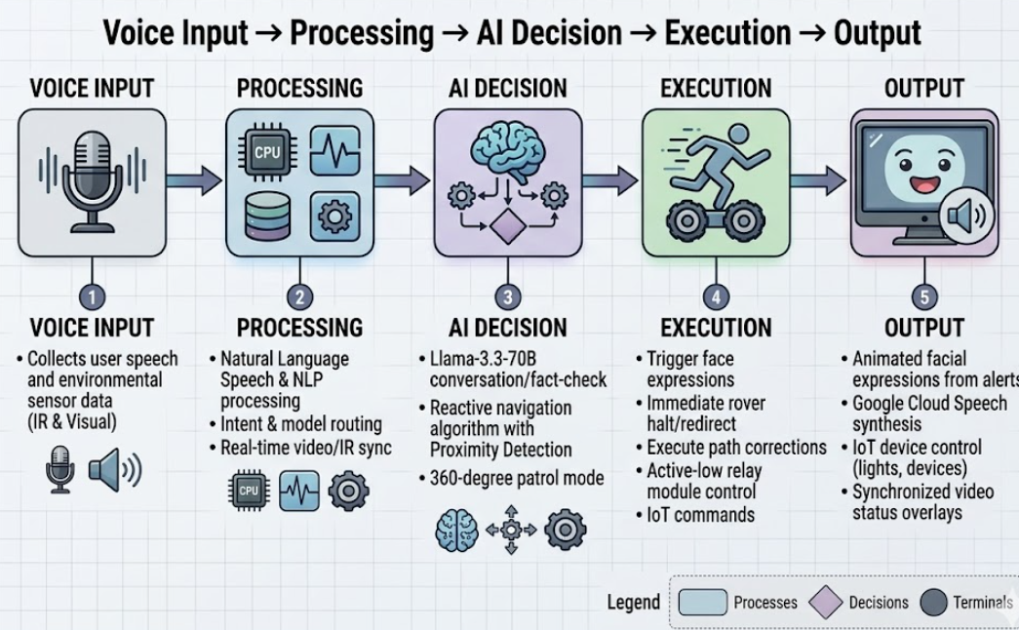
This project presents the Cybernetic Surveillance Rover, an intelligent and voice-controlled robotic system designed to overcome the limitations of traditional surveillance and home automation systems. Conventional systems are passive in nature and require continuous human monitoring, which reduces efficiency and increases dependency on manual supervision. In contrast, the proposed system introduces an active, mobile, and interactive platform capable of performing autonomous surveillance and intelligent decision-making.
Figure 3.1: Overall Methodology Flow of Cybernetic Surveillance Rover
Figure 3.1 illustrates the complete operational workflow of the Cybernetic Surveillance Rover, structured as a sequential pipeline consisting of five major stages: Voice Input, Processing, AI Decision, Execution, and Output.
The process begins with the Voice Input stage, where the system captures user speech through a microphone. In addition to voice commands, environmental data from infrared (IR) sensors and visual inputs are also collected. This enables the system to simultaneously understand user intent and monitor surroundings.
In the Processing stage, the captured input undergoes natural language processing (NLP) and speech analysis. The system converts speech into text and performs intent recognition. At the same time, sensor data and real-time video inputs are synchronized. This stage ensures that both user commands and environmental conditions are accurately interpreted.
The processed information is then passed to the AI Decision stage, which acts as the core intelligence layer. Here, advanced AI models analyze the input to determine the appropriate action. The system performs tasks such as conversational reasoning, navigation decision-making using proximity detection, and enabling 360-degree autonomous patrol behavior.
Following decision-making, the system moves to the Execution stage, where commands are translated into physical actions. The rover performs movement operations such as forward motion, stopping, or redirection based on obstacle detection. It also controls IoT devices through relay modules and updates system expressions to reflect its operational state.
Finally, in the Output stage, the system provides feedback to the user. This includes voice responses generated through speech synthesis, animated facial expressions displayed on the interface, real-time video updates, and IoT device status. This feedback loop ensures continuous interaction and transparency in system behavior.
Overall, the diagram represents a closed-loop intelligent system where sensing, processing, decision-making, and execution are tightly integrated to enable autonomous operation and user-friendly interaction.
The methodology is based on a dual-controller architecture, where the Raspberry Pi 5 performs high-level processing tasks such as artificial intelligence, voice recognition, and vision processing, while the ESP32 handles real-time hardware control. This separation of responsibilities improves system performance, reduces processing delays, and enhances reliability. The integration of intelligent navigation and automation is inspired by modern robotic systems and autonomous control techniques [1],[2].
3.2 TRADITIONAL VS PROPOSED SYSTEM
Traditional surveillance and automation systems are limited by their dependence on manual control and lack of integration. Surveillance systems typically consist of static cameras that provide only visual monitoring without any ability to interact or respond. Similarly, IoT-based home automation systems require multiple applications for controlling different devices, resulting in a fragmented user experience.
The proposed system overcomes these limitations by introducing a unified and intelligent platform. It utilizes voice-based interaction, allowing users to communicate naturally with the system. The integration of an ESP32-based relay module enables centralized control of appliances, while a multi-sensor infrared array supports autonomous navigation. This combination of features enhances usability, efficiency, and adaptability in real-time environments [2],[5].

3.3 SYSTEM ARCHITECTURE AND HARDWARE INTEGRATION
The system architecture follows a hierarchical and distributed model. The Raspberry Pi 5 acts as the primary controller responsible for AI processing, speech recognition, and user interface management. The ESP32 functions as a secondary controller that manages real-time operations such as relay switching and peripheral interfacing.
The locomotion system is implemented using an L298N motor driver connected to DC motors, enabling directional movement and speed control through PWM signals. A six-sensor infrared (IR) array is deployed around the rover to provide 360-degree obstacle detection. This sensor configuration enhances environmental awareness and supports adaptive navigation in dynamic indoor conditions [3],[4].
The relay module, controlled by the ESP32, is used to switch electrical appliances safely in a demonstration environment. This hardware integration ensures smooth coordination between processing, sensing, and actuation components.
3.4 EMBEDDED SOFTWARE DESIGN
The embedded software is developed using a modular approach in Python to improve scalability and maintainability. Each functional unit of the system is implemented as a separate module, enabling independent development and testing.
The motor control module generates control signals for movement, while the sensor module continuously monitors IR sensor inputs. The AI routing module processes user commands and directs them to appropriate execution modules. This modular design ensures efficient task management and reduces system complexity.
A dual-model AI system is incorporated, where one model handles conversational processing and reasoning tasks, while another model is used for real-time information retrieval. This approach enhances response accuracy and ensures efficient handling of diverse user queries [6].
Voice interaction is achieved through speech recognition for input processing and text-to-speech synthesis for output generation, enabling natural and intuitive communication.
Table 3.1 – System Modules and Functions
Module | Function
motor_control.py | Motor movement
ir_sensors.py | Obstacle detection
ai_router.py | AI decision making
speech module | Voice processing
home_automation.py | IoT control
Table 3.1 presents the modular software architecture of the Cybernetic Surveillance Rover, highlighting the key functional modules and their respective roles within the system. The design follows a structured and modular approach, where each module is responsible for a specific operation, ensuring better maintainability, scalability, and system efficiency.

The motor_control.py module is responsible for controlling the movement of the rover. It generates appropriate control signals to the motor driver, enabling
directional movements such as forward, backward, left, and right, as well as speed control using PWM techniques.
The ir_sensors.py module handles obstacle detection by continuously reading input from the infrared sensor array. It processes real-time proximity data and provides immediate feedback to the system, allowing safe navigation and collision avoidance.
The ai_router.py module acts as the central decision-making unit. It processes user commands, identifies intent, and routes tasks to the appropriate modules. This ensures efficient coordination between different components such as navigation, automation, and interaction.
The speech module is responsible for voice interaction. It performs speech-to-text conversion to understand user commands and text-to-speech synthesis to generate system responses. This enables natural and intuitive communication between the user and the rover.
The home_automation.py module manages IoT-based device control. It communicates with the ESP32 to operate the relay module, allowing the system to switch electrical appliances based on user commands.
Overall, the table demonstrates how the system is divided into independent yet interconnected modules, enabling efficient execution of tasks and smooth integration of hardware and software components.

3.5 POWER MANAGEMENT AND SAFETY
Power management is designed to ensure stable and efficient operation of all system components. The Raspberry Pi and ESP32 operate on a regulated 5V supply, while the motors require a 12V power source.
A relay-based switching mechanism is used for controlling electrical devices safely during demonstration. Proper isolation techniques and grounding methods are implemented to minimize electrical noise and protect sensitive components. These measures improve system reliability and prevent damage due to voltage fluctuations.

3.6 OPERATIONAL FLOW
The system operates based on a continuous loop of sensing, processing, and execution. Sensor inputs and voice commands are continuously monitored in real time.
START
SENSOR INPUT
DATA CAPTURE

AI PROCESSING
DECISION MAKING
MOTOR CONTROL

ACTION OUTPUT
END
Figure 3.2: Operational Flow of System
Figure 3.2 shows the workflow of the system. The process begins with sensor input, where data is collected from different modules such as cameras and proximity sensors. The data is then processed by the AI engine, which analyzes the environment and makes decisions based on trained intelligence. After decision-making, control signals are sent to motor drivers to execute movement or actions. This continuous loop ensures real-time responsiveness and autonomous operation of the system.
The input data is processed using natural language processing techniques to identify user intent. Based on the analysis, the system determines the appropriate action, such as navigation, appliance control, or response generation. This real-time decision-making capability improves system responsiveness and user experience [2],[5].
3.7 SYSTEM COMMUNICATION AND CONTROL
The communication between the Raspberry Pi and ESP32 is established through a WiFi-based protocol. The Raspberry Pi acts as the central control unit, managing high-level processing and decision-making tasks.
The ESP32 executes real-time hardware operations such as relay control and peripheral management. This distributed communication model improves system efficiency, reduces latency, and ensures smooth coordination between software and hardware components [4].
3.8 POWER ELECTRONICS AND SAFETY MECHANISM
The system integrates low-voltage control circuits with electrical devices using an 8-channel relay module. Optocoupler isolation is implemented to protect the ESP32 from electrical noise and back-EMF effects.
For demonstration purposes, only low-power loads are used. Direct switching of high-power inductive loads is avoided to ensure safety. This approach ensures a reliable and practical implementation suitable for academic environments.
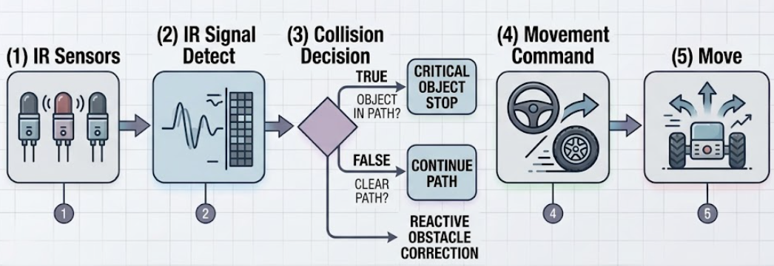
Figure 3.3: Relay-Based Switching Mechanism
Figure 3.3 illustrates the working process of the infrared (IR) sensor-based obstacle detection and navigation system used in the Cybernetic Surveillance Rover. This flow represents how the rover senses obstacles, makes decisions, and performs movement actions in real time.
The process begins with the IR Sensors stage, where multiple infrared sensors are positioned around the rover to provide environmental awareness. These sensors continuously emit and receive infrared signals to detect nearby objects.
In the IR Signal Detection stage, the system reads and processes signals reflected from obstacles. The sensor outputs are converted into electrical signals, which indicate the presence or absence of objects in the rover’s path.
The system then moves to the Collision Decision stage, where a logical decision is made based on sensor data. If an object is detected in the path (TRUE condition), the system identifies it as a potential collision risk. If no obstacle is detected (FALSE condition), the path is considered clear.
Based on this decision, the system performs Reactive Obstacle Correction. In case of obstacle detection, a critical object stop command is triggered to immediately halt the rover. If the path is clear, the rover continues its movement without interruption.
Next, in the Movement Command stage, appropriate control signals are generated for the motor driver. These commands determine the rover’s direction, such as moving forward, turning, or stopping.
Finally, in the Move stage, the rover executes the commanded action using its motors. This completes one cycle of sensing, decision-making, and action.
3.9 MODULAR SOFTWARE IMPLEMENTATION
The software architecture follows a modular design that allows independent operation of system components. Each module performs a specific function, improving maintainability and scalability.
The motor control module handles movement operations, while the sensor module ensures real-time obstacle detection. The AI routing module processes user input and directs tasks efficiently, enabling smooth interaction between software and hardware components [6].
3.10 AUTONOMOUS PATROL AND OBSTACLE AVOIDANCE
The autonomous navigation system is based on a reactive obstacle avoidance algorithm using a six-sensor IR array. This enables continuous monitoring of the environment and dynamic response to obstacles.
The navigation process involves sensing, detection, and corrective action. When an obstacle is detected, the system immediately responds by stopping, reversing, or changing direction. This ensures safe and efficient movement in indoor environments [3].

3.11 SOFTWARE FRAMEWORK
The software framework is designed using a multi-threaded architecture to enable simultaneous execution of multiple tasks such as voice processing, navigation, and display updates. This ensures real-time system performance and responsiveness.
3.11.1 Data Acquisition and Pre-processing
The system processes both audio and visual inputs. Audio data is captured and converted into text using speech recognition techniques. The processed text is analyzed to determine user commands.
Visual data is captured through a camera module and processed to provide real-time feedback and system status updates.
3.11.2 Intelligence Layer (Dual-Model AI Architecture)
The system integrates a dual-model AI architecture where one model handles conversational interaction and another handles real-time information retrieval. This improves system efficiency and response accuracy [6].
3.11.3 Hardware Control and Execution Logic
The execution layer converts processed data into physical actions. Movement is controlled through motor drivers, while navigation is managed using sensor feedback.
For IoT operations, commands are transmitted to the ESP32, which controls relay modules to switch devices. The system continuously updates the interface and provides feedback, ensuring smooth and efficient operation.
CHAPTER 4
ENHANCED OPERATIONAL MODEL
4.1 Motivation for Developing the Project
Project GOKU is developed to overcome the limitations of passive surveillance systems and fragmented home automation solutions. Traditional CCTV systems require continuous manual monitoring and provide only fixed coverage. Similarly, existing IoT-based systems depend on multiple applications for control, making them complex and less efficient.
To address these limitations, GOKU introduces a mobile, voice-controlled cybernetic robotic platform that integrates autonomous navigation with natural language interaction. The use of a Raspberry Pi 5 as the main processing unit and an ESP32 as a secondary controller ensures efficient handling of AI computation and real-time hardware control.
Safety and reliability are key design motivations. A six-sensor IR array provides 360-degree obstacle detection for collision-free movement. Industrial-grade AC contactors are used for safe control of high-power appliances such as air conditioners and pumps. A dual-model AI architecture further enhances performance by separating conversational intelligence from real-time data processing. Overall, the system delivers a smart, safe, and user-friendly solution for modern home environments.
4.2 Hardware Architecture
The GOKU rover is built on a structured hardware design that integrates sensing, processing, and safe actuation.
4.2.1 Sensory and Vision Input Layer
A six-sensor IR array is used for real-time obstacle detection, enabling safe navigation in all directions. A CP PLUS surveillance camera module is integrated with OpenCV to provide live video streaming and visual monitoring.
4.2.2 Dual-Controller Processing Unit
The Raspberry Pi 5 handles AI processing, voice recognition, and user interface rendering. The ESP32 microcontroller manages relay-based IoT control operations. This separation improves system performance, stability, and scalability.
4.2.3 AI Routing and Control Logic
The system uses intent-based processing to interpret user voice commands for movement, automation, and information retrieval. Sensor inputs are given highest priority to ensure safety during autonomous operation.
4.2.4 Locomotion and Power Interface
Movement is controlled using 12V DC motors driven by an L298N motor driver. For high-power electrical loads, Schneider Electric TeSys D AC contactors are used along with relay modules to ensure safe and isolated switching of 220V appliances.
This hardware design ensures efficiency, reliability, and suitability for real-world smart home applications.

4.3 Control System Architecture
The control system of the GOKU Cybernetic Surveillance Rover is designed to ensure accurate response to user commands while maintaining real-time safety during operation. It combines intelligent decision-making with fast hardware-level response mechanisms, enabling both smooth human interaction and reliable autonomous behavior.
4.3.1 Dual-Model AI Intent Routing and Reactive Control
The system follows a hierarchical control strategy where high-level reasoning and low-level safety operate simultaneously. User commands are processed using a dual-model AI approach, where conversational queries and real-time processing tasks are handled separately. At the same time, a continuous hardware monitoring loop ensures immediate obstacle detection using a six-sensor IR array. This integration allows the rover to respond intelligently while prioritizing safety.
4.3.1.1 System Workflow with Intent-Based Control
The operation begins with capturing voice input through a microphone, which is converted into text format. The system then processes the input through the following stages:
- Intent detection identifies whether the command is related to movement, home automation, or information retrieval.
- Logic routing directs the request to the appropriate AI model or processing module.
- Hardware execution converts commands into physical actions, such as
motor movement via the L298N motor driver or appliance control via the ESP32.
- Safety interrupt continuously monitors IR sensors and overrides all commands by immediately stopping the motors when an obstacle is detected.
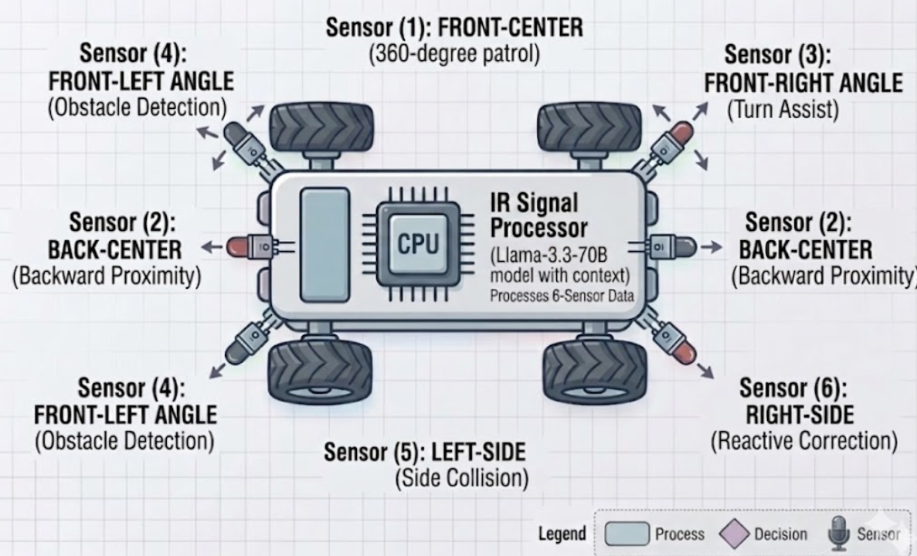
Figure 4.1: IR Sensor Placement (360° Coverage)
Figure 4.1 illustrates the 360-degree placement of the IR sensor array around the rover. The sensors are strategically positioned to ensure complete directional coverage for obstacle detection, enabling safe and efficient autonomous navigation in indoor environments.
4.3.1.2 Advantages of the Control Strategy
The control system enables natural interaction through voice commands instead of fixed inputs. It ensures high safety by prioritizing sensor-based interrupts over AI decisions. The architecture also supports industrial-level applications by safely controlling high-voltage devices using contactors. Additionally, real-time feedback is provided through voice responses and a graphical user interface, enhancing user experience.
4.3.1.3 Challenges and Limitations
The system depends on internet connectivity for advanced AI features, and API limitations may restrict frequent requests. Electrical noise from high-power devices may affect system stability if proper isolation is not maintained. Power management is critical, as multiple components such as Raspberry Pi 5, motors, and display require stable power supply. Minor latency may also occur between voice input and execution due to processing overhead.
4.4 Hardware Modules
4.4.1 6-Sensor Infrared (IR) Array
The GOKU rover uses a distributed array of six infrared sensors to achieve 360-degree environmental awareness. Each sensor detects obstacles using reflected IR signals and outputs a LOW logic signal when an object is detected. These signals are continuously monitored by the Raspberry Pi 5 through the ir_sensors.py module. When an obstacle is detected, motor PWM signals to the L298N driver are disabled, ensuring immediate stop and collision prevention.
4.4.2 Surveillance Camera (CP PLUS)
A CP PLUS surveillance camera is mounted on the rover for live monitoring. Unlike fixed CCTV systems, this mobile camera provides dynamic coverage

of blind spots. The video stream is processed using OpenCV on the Raspberry Pi 5, enabling real-time streaming and basic image processing capabilities.
4.4.3 8-Channel Relay Module (Opto-Isolated)
The home automation system uses an 8-channel relay module controlled by the ESP32. The relay operates on Active-Low logic, where a LOW signal activates the relay. Optocoupler isolation ensures separation between low-voltage control signals and high-voltage AC loads. This allows safe control of household appliances such as lights and fans.
4.4.4 Schneider Electric TeSys D AC Contactors
For high-power appliances such as air conditioners and water pumps, Schneider Electric TeSys D contactors are used. The relay module triggers the contactor coil instead of directly switching high loads. This approach reduces electrical stress on relays, improves safety, and ensures reliable switching of high-voltage systems.
4.4.5 Display Unit (User Interface)
The system uses a display connected to the Raspberry Pi 5 for visual output. This display is not touch-enabled and is used to show the animated GOKU interface and system status. Using the Pygame library, the system displays expressions such as idle, alert, and active states along with sensor and system information.
4.4.6 Power Supply and Battery Architecture
The system follows a dual power supply design. A 12V supply is used for motors and actuators, while a regulated 5V supply powers the Raspberry Pi 5 and ESP32. This separation prevents electrical noise interference and ensures stable operation of the entire system.
4.5 Software and Development Technologies
The GOKU project uses a modular software stack to integrate artificial intelligence with embedded hardware systems.
- Python (3.10–3.11): Primary development language for AI, control logic, and system integration.
- AI Ecosystem: Uses Llama-3.3-70B-Versatile (via Groq API) for conversational reasoning and Gemini 2.5 Flash (via Google GenAI SDK) for real-time data retrieval.
- Speech Processing: Google Speech API is used for speech-to-text conversion, and gTTS or pyttsx3 provides voice output.
- IoT Communication: Blynk IoT platform and HTTP APIs enable communication between Raspberry Pi and ESP32.
- Development Tools: PlatformIO and Arduino IDE are used for ESP32 programming, while Python environments are used for Raspberry Pi development.

CHAPTER 5
TECHNOLOGY STACK
5.1 TOOLS AND TECHNOLOGIES EMPLOYED
The GOKU voice-controlled surveillance rover integrates embedded hardware, software frameworks, and AI-based cloud services to enable real-time perception, decision-making, and physical interaction.The system is divided into three major categories:
1. Hardware Technology Stack
Raspberry Pi (main processing unit), ESP32 microcontroller, IR sensors, ultrasonic sensors, relay modules, motor drivers, and actuators are used for mobility, sensing, and electrical control.
2. Software Technology Stack
Python is used for system integration along with OpenCV for vision processing, speech recognition libraries for voice input, and text-to-speech engines for output interaction.
5.2 HARDWARE TECHNOLOGY STACK
The GOKU Cybernetic Surveillance Rover is built using a carefully selected set of embedded hardware components that collectively support autonomous navigation, AI-based decision-making, real-time sensing, and safe industrial-level home automation. These tools ensure reliable coordination between computation, control, and physical interaction.
5.2.1 Core Processing Unit – Raspberry Pi 5 (8GB)
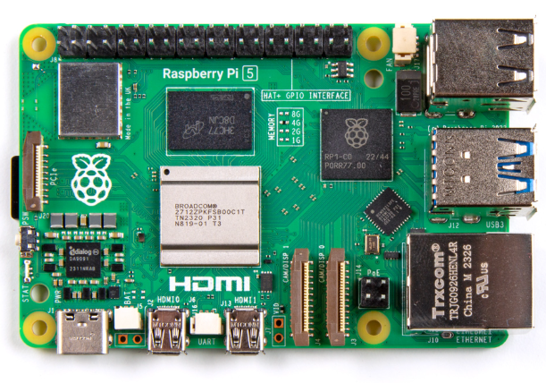
The Raspberry Pi 5 acts as the central cognitive hub of the system. It handles high-level operations such as real-time AI processing, OpenCV-based vision tasks, speech recognition, and graphical user interface rendering. It also manages coordination between sensors, motors, and IoT devices, making it the main intelligence unit of the rover.
Figure 5.1 – Raspberry Pi 5

Figure 5.1 represents the Raspberry Pi 5 (8GB), which acts as the central processing unit of the GOKU system. It handles high-level tasks such as AI processing, computer vision using OpenCV, voice recognition, and user interface rendering. It also coordinates communication between sensors, motors, and IoT modules, making it the primary intelligence unit of the rover.
5.2.2 IoT Control Unit – ESP32 Developer Kit (ESP32-WROOM-32)The ESP32 functions as a secondary microcontroller dedicated to IoT and home automation tasks. It receives commands from the Raspberry Pi over WiFi and controls the 8-channel relay module. This separation reduces processing load on the main system and improves real-time response for hardware switching operations.

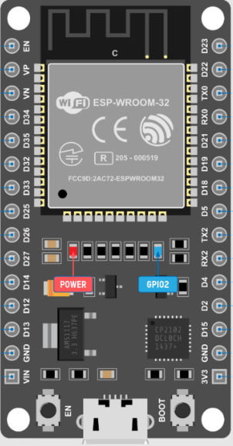

Figure 5.2 – ESP32
Figure 5.2 shows the ESP32 microcontroller used as the IoT control unit. It receives commands from the Raspberry Pi via WiFi and controls relay modules for home automation tasks. It enables efficient distributed processing by handling real-time switching operations independently from the main processor.
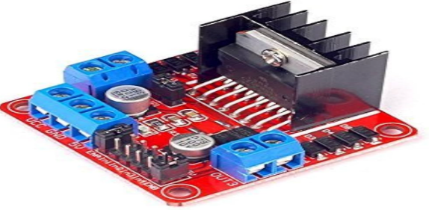
5.2.3 Motor Driver – L298N Dual H-Bridge Module
Figure 5.3 – Motor Control System (L298N Interface)
Figure 5.3 illustrates the L298N dual H-bridge motor driver used for controlling the DC motors of the rover. It converts low-power control signals from the Raspberry Pi into high-power outputs required for motor operation. It supports bidirectional movement and PWM-based speed control for smooth navigation.
The L298N motor driver acts as an interface between the Raspberry Pi and DC motors. It enables bidirectional control and speed regulation using PWM signals, allowing precise movement control for navigation and turning operations.

The L298N Dual H-Bridge Motor Driver is a key hardware component in the GOKU Cybernetic Surveillance Rover, responsible for controlling the motion of the two 12V high-torque geared DC motors. It acts as the power interface between the low-voltage control signals from the Raspberry Pi 5 and the high-power requirements of the locomotion system. With its ability to handle a wide operating voltage range (5V–35V) and provide up to 2A continuous current per channel, the L298N is well-suited for robotics applications requiring reliable bidirectional motor control.
In the system architecture, the L298N functions as the execution layer for movement commands generated by the AI-driven Raspberry Pi 5. The Raspberry Pi processes voice inputs and AI decisions (such as “move forward,” “turn left,” or “stop”) and converts them into digital logic signals and PWM outputs. These signals are sent to the L298N, which then determines motor direction and speed accordingly. This allows smooth translation of natural language commands into real-world movement.
A major advantage of the L298N module is its support for Pulse Width Modulation (PWM), which enables precise speed control by varying the effective voltage delivered to the motors. This allows the rover to perform smooth acceleration, deceleration, and controlled turning rather than abrupt motion. It improves navigation accuracy during indoor surveillance and autonomous patrol operations.

The module also includes built-in flyback diodes, which protect the control circuitry from back-EMF generated by inductive motor loads. This is critical for safeguarding the Raspberry Pi 5 and ESP32 from voltage spikes during sudden motor stops or directional changes. Additionally, its dual H-bridge structure enables independent control of both motors, supporting differential drive movement essential for turning and rotation.
For safety, the L298N is tightly integrated with the rover’s IR sensor array. When an obstacle is detected, the Raspberry Pi immediately interrupts PWM signals, forcing the L298N to stop or reverse motor operation. This ensures real-time collision avoidance during autonomous navigation.
5.2.4 Drive System – 12V Geared DC Motors
Two high-torque DC motors are used for rover movement. Configured in a differential drive setup, they provide stable locomotion and allow sharp turning capabilities, enabling efficient indoor and outdoor navigation.
5.2.5 Safety Sensors – 6-Sensor IR Array
A distributed infrared sensor array provides 360-degree obstacle detection. These sensors continuously monitor the environment and immediately stop motion when an obstacle is detected, ensuring collision-free autonomous operation.
5.2.6 Relay System – 8-Channel Opto-Isolated Module
The relay module is used for controlling electrical appliances. Optocoupler isolation ensures safe separation between low-voltage control circuits and high-voltage AC loads, improving system safety and reliability.
5.2.7 High-Power Switching – AC Contactors
Industrial-grade Schneider Electric contactors are used for heavy electrical loads such as pumps and air conditioners. They act as secondary switches controlled by relays, ensuring safe handling of high inrush current.
5.2.8 User Interface – 7” HDMI
The touchscreen display serves as the Human-Machine Interface (HMI). It provides system status, animated AI feedback, and real-time interaction with the rover’s control system.
5.2.9 Vision System – CP Plus Surveillance Camera
An external HD camera is integrated for live video streaming and object monitoring. It works with OpenCV to support real-time surveillance and visual processing tasks.
5.2.10 Power System – Dual Power Architecture
A dual power setup ensures stable operation. A 12V supply powers the motors, while a regulated 5V supply powers the Raspberry Pi and control electronics, preventing voltage drops and system instability.
5.2.11 Technical Specifications
- Operating Voltage: 5V – 35V (suitable for 12V motor system)
- Output Current: Up to 2A per channel
- Configuration: Dual H-Bridge for independent motor control
- Control Interface: TTL logic compatible with Raspberry Pi GPIO
- Protection: Built-in flyback diodes for back-EMF suppression
- PWM Support: Enables speed regulation and smooth motion control
- Grounding: Common GND shared with Raspberry Pi and ESP32 for signal stability
5.2.12 Wiring and Interfacing (Raspberry Pi 5 Integration)
The L298N is directly interfaced with the Raspberry Pi 5 GPIO pins for control and PWM-based speed modulation. The IN1–IN4 pins are connected to GPIO outputs, which determine motor direction (forward/reverse). The ENA and ENB pins receive PWM signals to control motor speed dynamically.
The OUT1–OUT4 terminals are connected to the two DC geared motors, while the motor power input is supplied through a 12V battery source. A common ground is maintained between the Raspberry Pi, ESP32, and L298N to ensure stable signal reference and prevent communication errors.
In addition, the motor control system is software-interlocked with the IR sensor array. When an obstacle is detected, the Raspberry Pi immediately disables PWM output, forcing the L298N to stop motor rotation. This real-time safety mechanism ensures collision-free operation during autonomous movement.

Table 5.1 – Hardware Stack
S.No | Hardware Component | Purpose | Key Function in GOKU Rover
1 | Raspberry Pi 5 (8GB) | Central processing unit | AI processing, vision, voice control
2 | ESP32 DevKit | IoT control unit | Relay control and WiFi communication
3 | L298N Motor Driver | Motor control | PWM-based speed and direction control
4 | 12V DC Geared Motors | Locomotion | Movement and navigation
5 | IR Sensor Array (6 Sensors) | Obstacle detection | 360° safety and collision avoidance
6 | 8-Channel Relay Module | Appliance control | Switching electrical loads
7 | AC Contactors | High-power switching | Safe control of heavy appliances
8 | 7” Touch Display | HMI interface | UI, animations, system display
9 | CP Plus Camera | Surveillance | Live video monitoring
10 | Dual Power System | Power management | Separate motor and logic supply
5.3 SOFTWARE STACK
The GOKU Cybernetic Surveillance Rover relies on a carefully selected software stack that enables real-time vision processing, voice interaction, AI-based decision-making, IoT communication, and hardware control. These software tools work together on the Raspberry Pi 5 to create a unified intelligent robotic system.
5.3.1 Computer Vision – OpenCV (opencv-python)
OpenCV is the core library used for all vision-based tasks in the rover. It processes live video streams from the surveillance camera in real time, enabling object monitoring and visual feedback. It is also used to render graphical overlays, including the animated GOKU face interface, making it essential for visual intelligence and surveillance operations.
5.3.2 Voice Processing – Speech Recognition & PyAudio
The voice control system is implemented using the Speech Recognition library along with PyAudio for microphone input. These tools allow the rover to capture and interpret spoken commands such as movement instructions, system checks, and camera activation. This forms the primary human–robot interaction method.
5.3.3 UI and Animation – Pygame
Pygame is used to build the Human-Machine Interface (HMI) displayed on the 7-inch touchscreen. It renders animated facial expressions representing system states such as idle, active, alert, or obstacle detection. It also supports video display and real-time UI updates based on user commands and system events.
5.3.4 Hardware Interfacing – RPi.GPIO & GPIO Libraries
These libraries provide direct access to Raspberry Pi GPIO pins for hardware control. They are used to generate PWM signals for the L298N motor driver and to read input signals from the IR sensor array. This enables precise motor control and real-time obstacle detection.

5.3.5 AI Integration – Groq API (Llama-3.3-70B)
The Groq library is used to integrate large language model capabilities into the system. It enables intelligent response generation, contextual reasoning, and advanced decision-making beyond predefined commands, making the rover capable of conversational AI interaction.
5.3.6 IoT Communication – Requests Library
The Requests library is used for HTTP-based communication between the Raspberry Pi 5 and the ESP32 module. It sends control signals for home automation tasks, such as switching appliances through the 8-channel relay system.
5.3.7 Speech Synthesis – pyttsx3 & gTTS
These text-to-speech engines enable the rover to respond verbally to users. They are used for system feedback, greetings, alerts, and status reports, making the interaction more natural and interactive.
5.3.8 Data Processing – BeautifulSoup4
Beautiful Soup is used for web scraping and extracting real-time data from online sources. This supports the rover in retrieving updated information such as weather, news, or system-related queries when required.
5.3.9 Event Handling – Blinker
The Blinker library is used for internal event management and communication between software modules. It helps trigger synchronized actions, such as activating UI animations when sensors detect obstacles or when specific system states change.

Table 5.2 – Software Stack
S.No | Software Tool | Purpose | Role in System
1 | OpenCV | Computer vision | Camera processing & detection
2 | SpeechRecognition & PyAudio | Voice input | Command recognition
3 | Pygame | UI system | Animated display & interface
4 | RPi.GPIO | Hardware control | GPIO & PWM control
5 | Groq API (LLM) | AI processing | Intelligent responses
6 | Gemini 1.5 Flash | AI & real-time data | Web-based query processing & fast response
7 | Requests | IoT communication | ESP32 control via HTTP
8 | pyttsx3 & gTTS | Speech output | Voice responses
9 | BeautifulSoup4 | Data extraction | Web scraping
10 | Blinker | Event handling | Module synchronization

CHAPTER 6
RESULTS AND DISCUSSION

6.1 SYSTEM SETUP AND WORKING PRINCIPLE
The GOKU Cybernetic Surveillance Rover is designed using a modular cyber-physical architecture consisting of a Cognitive Processing Unit (Raspberry Pi 5) and a Hardware Actuation Layer (ESP32 + Motor/Relay systems). This separation enables real-time AI processing along with reliable physical control and safety execution [1], [2].
The system operates through three main functional layers: perception, decision-making, and actuation.

6.1.1 Sensory Perception System
The sensory layer provides real-time environmental awareness using multiple input sources:
- IR Sensor Array (6 Sensors): Provides 360° obstacle detection for collision avoidance during navigation [3].
- CP PLUS Camera + OpenCV: Enables live video streaming and visual monitoring of surroundings [4].
- Voice Interface: Captures user commands through a microphone and processes them using Google Speech API [5].
The processed inputs are sent to the Raspberry Pi 5 for interpretation and decision-making using a dual AI model system [6].

6.1.2 Control and Actuation System
Once input is processed, the system executes actions through hardware modules:
- Locomotion1Control:
The L298N motor driver controls two 12V DC motors using PWM signals generated by Raspberry Pi 5, enabling forward, reverse, and turning operations [7].
- Home1Automation2Control:
The ESP32 receives commands via WiFi and operates an 8-channel relay module for appliance control [2].
- Industrial1Safety2Control:
High-power appliances are controlled using AC contactors triggered via relay outputs, ensuring safe switching of 220V loads [8].
This layered architecture ensures reliable execution of both AI-driven and safety-critical operations.

6.1.3 Power and Electrical Architecture
The system uses a dual power supply design for stability:
- 12V Supply: Powers motors and L298N motor driver
- 5V Supply: Powers Raspberry Pi 5 and ESP32
Electrical isolation is maintained using separate power rails and opto-isolated relay modules to prevent noise interference and system resets [8].

6.2 TESTING AND IMPLEMENTATION
The system was tested in a controlled environment simulating indoor navigation, obstacle-rich paths, and appliance control scenarios.

6.2.1 Navigation and Obstacle Avoidance
- IR sensors successfully detected obstacles in real time [3]
- Rover performed automatic stop and directional correction
- Autonomous navigation was stable in constrained environments
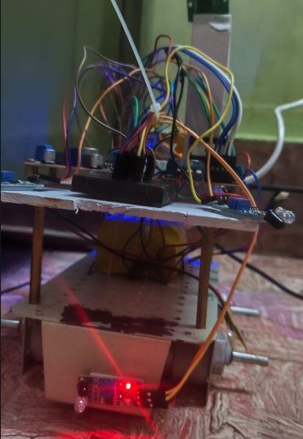

Figure 6.1: GOKU Rover Hardware Setup During Testing
This figure 6.1 shows the actual hardware implementation of the GOKU Cybernetic Surveillance Rover during testing. It includes the Raspberry Pi 5, ESP32 module, L298N motor driver, IR sensor array, and power supply system integrated on the rover chassis. The setup demonstrates the real-time integration of sensing, processing, and actuation units used for autonomous navigation and control.

6.2.2 Voice and AI System Testing
- Voice commands like “move forward”, “turn left” were correctly executed [5]
- Dual AI system worked efficiently:
  - Llama-3.3 handled reasoning and conversation [6]
  - Gemini 2.5 handled real-time web queries [6]

6.2.3 Home Automation Testing
- ESP32 successfully controlled all 8 relay channels [2]
- AC contactor switching was stable and safe [8]
- High-power appliances operated without failure

6.2.4 Surveillance and UI Testing
- CP PLUS camera provided stable live streaming via OpenCV [4]
- UI displayed real-time system status and animations
- Voice + visual feedback improved user interaction
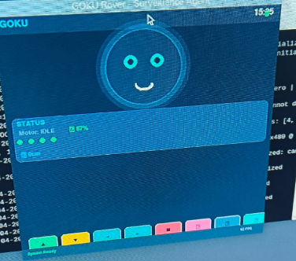
Figure 6.2: GOKU System User Interface with Real-Time Status Display
This figure 6.2 represents the graphical user interface of the GOKU system displayed on the 7-inch screen. It shows real-time system status, AI interaction feedback, and animation-based expressions indicating system states such as idle, active, and obstacle detection. The UI enhances user interaction by providing both visual and functional feedback during operation.

6.2.5 System Performance Summary
- High accuracy in command recognition [5]
- Fast obstacle detection response [3]
- Stable AI + hardware integration [6]
- Reliable operation under continuous load

6.3 PERIPHERAL DEVICE OUTPUT
The system converts AI decisions into real-world outputs through three layers:
(a) Locomotion Output
- Motor control via L298N driver [7]
- Supports forward, backward, and turning
- Emergency stop activated by IR sensors [3]
(b) Automation Output
- ESP32 controls relay system via WiFi [2]
- AC contactors handle heavy electrical loads safely [8]
(c) User Interface Output
- 7-inch display shows system status and animations
- Voice feedback provided using text-to-speech

6.3.1 Feedback and Safety Mechanism
The system includes a continuous feedback loop:
- IR sensor priority override for safety [3]
- Immediate motor shutdown on obstacle detection
- Synchronized voice and visual alerts

6.4 COMPARISON OF EXISTING AND PROPOSED SYSTEM
The GOKU system overcomes limitations of traditional surveillance and automation systems by integrating mobility, AI, and unified control.
Table 6.1: Comparison of Existing and Proposed System Functionalities
S.No | Parameters | Existing System | Proposed System (GOKU Rover)
1 | Control Mechanism | Manual or app-based control | Voice-based AI intent system
2 | Surveillance | Fixed CCTV | Mobile autonomous rover
3 | Intelligence | Rule-based system | Dual AI (Llama + Gemini)
4 | Obstacle Detection | Not available | 360° IR sensor system
5 | Home Automation | Separate apps | Unified ESP32 control system
6 | Feedback System | Basic alerts | Voice + UI + visual feedback
7 | Safety | Limited protection | Industrial-grade safety design
8 | Scalability | Limited expansion | Modular AI-ready architecture
9 | Cost | High-cost systems | Low-cost (~₹20,000–₹22,000)

CHAPTER 7
CONCLUSION AND FUTURE WORK

7.1 CONCLUSION
The Cybernetic Surveillance Rover represents an advanced integration of robotics, artificial intelligence, embedded systems, and IoT-based automation into a unified intelligent platform. The system successfully combines autonomous navigation, voice-based interaction, real-time surveillance, and smart appliance control within a single operational framework. By integrating a Raspberry Pi 5 for high-level processing and an ESP32 for real-time hardware control, the project achieves efficient task distribution, stable system performance, and responsive human-machine interaction [1], [2].
The proposed system overcomes several limitations of traditional surveillance and home automation systems. Unlike conventional CCTV-based monitoring systems that require continuous human supervision, the rover provides active and mobile surveillance through autonomous patrol capabilities [3], [4]. The integration of a six-sensor infrared array enables real-time obstacle detection and safe navigation, while the AI-based architecture allows natural voice communication and intelligent decision-making [3], [6].
The system also demonstrates successful implementation of IoT-based automation using relay control mechanisms for appliance switching. The use of modular software architecture improves maintainability, scalability, and efficient coordination between sensing, processing, and execution modules. Technologies such as OpenCV, speech recognition, and AI-based routing further enhance the intelligence and usability of the platform.
The developed rover successfully performs multiple functions including voice-controlled navigation, autonomous obstacle avoidance, real-time camera surveillance, and intelligent response generation. Experimental implementation confirms that the system operates reliably in indoor environments and provides smooth interaction between software intelligence and hardware execution. The integration of robotics, AI, and IoT into a single system demonstrates the feasibility of intelligent cybernetic platforms for modern smart environments.
Despite its capabilities, the system has certain limitations. Some advanced functionalities depend on internet connectivity and cloud-based AI services, which may introduce response delays. Additionally, infrared sensors can be affected by lighting conditions and reflective surfaces, slightly reducing navigation accuracy in complex environments. However, these limitations do not significantly affect the overall performance of the system.
Overall, the Cybernetic Surveillance Rover provides a cost-effective, scalable, and intelligent solution for modern surveillance and automation applications. The project successfully bridges the gap between digital intelligence and real-world interaction, making it suitable for future smart home, security, and assistive robotic applications.

7.2 FUTURE WORK
Future enhancements of the Cybernetic Surveillance Rover will focus on improving navigation intelligence, system autonomy, and environmental awareness. Advanced technologies such as LiDAR and SLAM-based mapping can be integrated to enable accurate localization and intelligent path planning in complex environments. The current IR sensor system can also be upgraded with depth sensors or computer vision-based navigation for improved obstacle detection and spatial awareness.
The artificial intelligence framework can be further enhanced using reinforcement learning and edge AI processing to enable adaptive behavior and reduced dependency on cloud-based services. Future versions may also include facial recognition, person tracking, gesture-based interaction, and predictive decision-making capabilities for enhanced human-robot interaction.
Additional improvements may include mobile application integration, remote monitoring, cloud-based analytics, and distributed IoT networking for large-scale smart home automation. Power optimization techniques such as automatic charging systems and energy-efficient control mechanisms can further improve operational efficiency and battery life.
In the long term, the system can evolve into a fully autonomous cognitive robotic assistant capable of intelligent learning, adaptive interaction, and real-time environmental understanding. These advancements would expand the application of the system in areas such as smart homes, industrial monitoring, healthcare assistance, and autonomous security systems.

REFERENCES

[1] S. Shirmohammadi, F. Baghbani, “Design and Implementation of a Line Follower Robot,” 2024 International Conference on Artificial Intelligence and Robotics. (Used for sensor-based navigation and autonomous movement logic in GOKU system)

[2] M. Pakdaman, M. M. Sanaatiyan, et al., “IoT-enabled Moving Wheelchair with Obstacle Detection and Continuous Health Monitoring,” 2024 International Conference on Emerging Trends in Information Technology and Engineering. (Used for IR sensor integration and ESP32-based IoT communication)

[3] N. N. N. Hisham, N. A. C. Mustapha, A. M. Ibrahim, “Indoor Navigation and Mapping for Wheelchair People in KOE,” 2023 International Conference on Computer and Communication Engineering. (Used for environment-aware navigation concepts)

[4] N. Charaspotiranatakul, W. Thitayanunwat, I. Rattanathavorn, “Curvature-Driven Kinematic Path Control for Line Follower Robot,” 2022 International Conference on Business and Industrial Research. (Used for PWM-based smooth motor control and kinematic motion design)

[5] M. Pakdaman, M. M. Sanaatiyan, “Design and Implementation of a Line Follower Robot,” 2009 International Conference on Computer and Electrical Engineering. (Used for differential drive motor control logic)

[6] D. Ding, B. Parmanto, H. A. Karimi, et al., “Design Considerations for a Personalized Navigation System,” 2007 IEEE Engineering in Medicine and Biology Society Conference. (Used for Human–Machine Interface design concepts)

[7] Google, “Gemini 2.5 Flash Generative AI Documentation,” Google AI Studio Documentation, 2024. (Used for real-time web-based AI response and natural language processing)

[8] Groq Inc., “Groq API Reference – Llama-3.3-70B Model Documentation,” 2024. (Used for high-speed AI inference and conversational reasoning)

[9] GeeksforGeeks, “Python and OpenCV Tutorials,” https://www.geeksforgeeks.org (Used for Python programming, multi-threading, and computer vision implementation)

[10] Last Minute Engineers, “Relay and Contactor Interfacing Guide,” https://lastminuteengineers.com (Used for hardware wiring, relay control, and AC contactor safety implementation)

